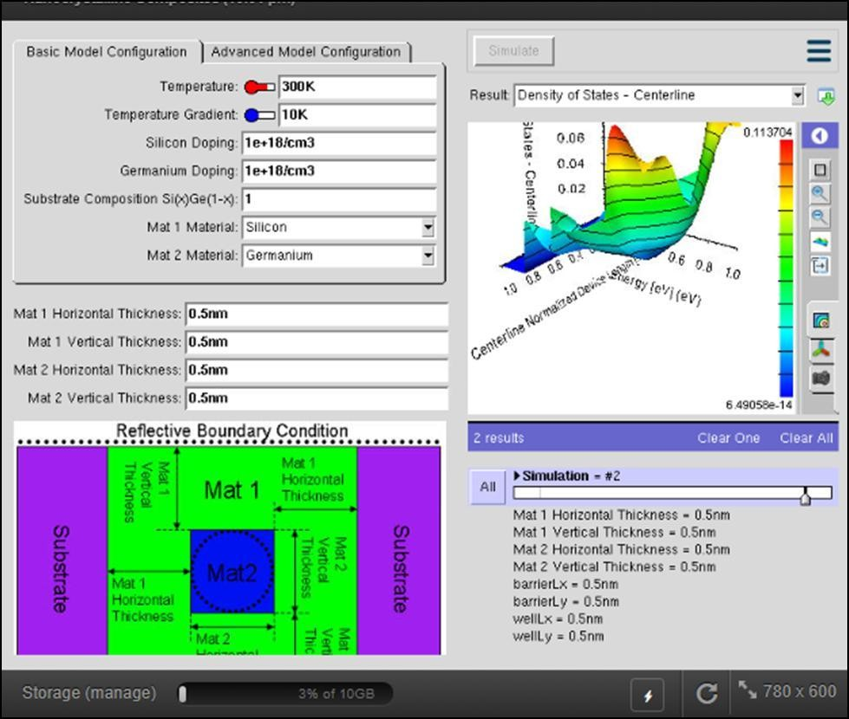
ECA5701-NANOELECTRONICS
A MOHAMED THALHA 192512160
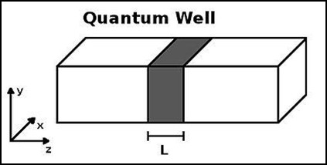
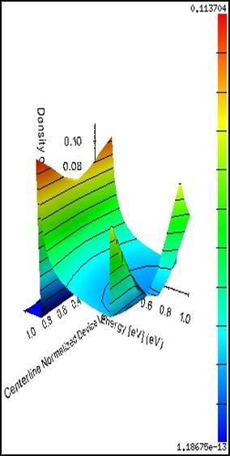
Exp. 2 – Density of States of Quantum Well Structure

